Comparison of the chemical compositions, physiochemical analysis and other bioactive compounds of various pumpkin (curcubita pepo l.) Varieties.
Huda, M. Ragab, Ibrahem, M. Abd El-Aleem and Abdalla El-Hadary*
Biochemistry Department, Faculty of Agriculture, Benha University, Benha 13736, Egypt.
*Corresponding author: elhadary.a@fagr.bu.edu.eg, https://orcid.org/0000-0002-5784-8606

Abstract
The chemical composition of Curcubita pepo Egyptian, Chinese seeds varieties and Egyptian leaves were studied. Total phenolic and total flavonoids compounds and scavenging radical effect on 2, 2-diphenylpicrylhydrazyl (DPPH) were investigated. The specific phenolic and flavonoid composition quantification for ethanolic and water extracts were performed by HPLC. From the obtained results, total lipid represents the major component of Curcubita pepo seeds (38.57-39.65%) followed by carbohydrate (28-31.75%) and protein (18.81-22.31%). The content of Curcubita pepo leaves, lipids and protein (6.30 – 11.81 %) was lower than of Curcubita pepo seeds. The oil obtained from the pumpkin seed's varieties, such as Egyptian and Chinese had refractive index value ranges from 1.467 to 1.469, specific gravity value ranges from 0.911 to 0.912, acid value ranges from 3.8 to 5.2 mg KOH/g oil, iodine ranges from (120.63 to131.87 mg I₂/100 g), saponification value ranges from 182.99 to 187.31 mg KOH/g and peroxide value ranges from 4.89 to 6.00 (meq O₂/kg oil). Pumpkin (Cucurbita pepo) oil contains a high amount of unsaturated fatty acids. The unsaturated fatty acids of Curcubita pepo oil were (79.03 and 78.79 %) of total fatty acids, respectively. The major unsaturated fatty acids in Egyptian and Chinese pumpkin seeds varieties oil were linoleic (50.22-49.51%) and oleic acid (28.82 -28.33%), while total saturated fatty acids content was (21.21-21.01%). The tocopherols content of Curcubita pepo Chinese seed oil was found to be 5.44 µg/mL of oil for α-tocopherol, 6.72 µg/mL of oil for γ -tocopherol and 10.72 µg/mL of oil for β-tocopherol. The tocopherols content of Curcubita pepo Egyptian seed oil was 7.69 µg/mL of oil for α-tocopherol and 1.22 µg/mL of oil for β-tocopherol. Total phenolic, total flavonoids and antioxidant activity content of ethanolic pumpkin leaves extracts were higher than aqueous extracts. Ethanolic pumpkin extracts were rich in phenolic compounds. The values were found to be highest quantities, cinnamic (8.33 µg/mL), syringic (5.10 µg/mL), pyrogallol (1.46 µg/mL), ellagic (0.97 µg/mL) and gallic (0.87 µg/mL). In additional to presence four flavonoid compounds were kampferol (16.84 µg/mL), apigenin (12.88 µg/mL), quercetin (4.55 µg/mL) and luteolin (1.64 µg/mL).

Key words: - Curcubita pepo seeds, pumpkin extracts, fatty acids, phenolic and flavonoid compounds.

Introduction

Since ancient times, pumpkins (Cucurbita spp.) have been widely cultivated and used as food. Several Cucurbita species, including C. pepo, C. moschata, C. maxima, and C. mixta, are grown in temperate and subtropical climates. (Tadmor et al., 2005). One of these species, Cucurbita pepo L., is a commercially significant member of the Cucurbitaceae family and one of the top ten vegetable crops in the world. (Lim, 2012). Each part of the pumpkin vegetable has useful applications in both food and medicine. (Sharma et al., 2020).
Different vegetal parts of Cucurbita pepo plants like flowers, fruit, seeds and young leaves are used for eating purpose. Seeds, leaves, sap, and pulp have medicinal uses that include treating urinary problems, intestinal worms, and other conditions. The gourds are used for a wide variety of decorative, historical, and industrial purposes, and the vines and fruit are fed to livestock. (Al Zuhair et al., 2000).
Pumpkin has a variety of biological and therapeutic properties, including anti-inflammatory, antioxidant, anti-cancer, anti-angiogenesis, hypolipidemic, and anti-diabetic properties. Tocopherols, carotenoids, triterpenes, phytosterols, lignans, and glycolipids were detected chemically. (Isutsa and Mallowa, 2013; Kim et al., 2012; Wang et al., 2012; Ayyildiz et al., 2019), in addition to protein, low carbohydrates, and fixed oil (Özbek and Ergönül, 2020). All pumpkin portions, including the edible seed, fruit, and leaves, offer a wide range of nutritional value as medicine or food, owing to their high levels of β-carotene and moderate levels of carbhydrates, vitamins, and minerals. (Rakcejeva et al., 2011)
Pumpkin seeds are rich in many essential compounds for the human body, such as polyunsaturated fatty acids (ω-3 and ω-6), squalene, phytosterols, phenolic compounds, tocopherols (α, β, γ, and δ), carotenoids, triterpenoids, and flavonoids (Singh and Kumar, 2021).
The leaves of pumpkin are functional vegetables due to their higher phenolics, flavonoid content, and antioxidant scavenging activity Ko et al., (2016), Cha et al., (2009) and Kim et al., (2011). In addition, leaves of pumpkin contain cinnamic acid, p-hydroxybenzoic acid, gentisic acid, protocatechuic acid, p-coumaric acid, ferulic acid, and caffeic acid.
Therefore, the aim of the present study is to evaluate chemical composition of pumpkin leaves and seeds varieties. Determination of physicochemical properties of pumpkin seeds oil, as well as fatty acids composition and tecols in oil. Total phenolic, total flavonoids compounds and antioxidant activity were estimated.

Materials and Methods

The Curcubita pepo (Egyptian, Chinese seeds varieties and Egyptian leaves) were obtained from local farm in Trisa village in Toukh, Qalyubia. Sample were collected in 2020. All chemicals used in these experiments were provided from Sigma and Al-Gomhoria chemical company of high quality and purity.
Analytical methods:
Moisture, total lipids, crude protein, ash, total carbohydrate and total fatty acids were determined according to the method of the Association of Official Analytical Chemists (A.O.A.C., 2019). Fatty acids were determined according to the method by (ISO,2011).
Determination of physicochemical properties of pumpkin oils:
Refractive index, specific gravity, acid value, peroxide value, saponification value and iodine value were determined according to A.O.A.C. (2019).
Determination of tocopherols of pumpkin seeds oil:
Analysis of tocopherols was performed by HPLC-(Agilent 1100) according to Liu et al., (1996).
Preparation of Curcubita pepo leaves extracts:
The dried leaves were powdered mechanically and extracted by different solvents including petroleum ether, chloroform, ethyl acetate, 80% ethanol and distilled water for 15 h for each solvent, using Soxhlet extractor. The extracts were filtered through Buchner funnel and evaporated under vacuum using a rotary evaporator (N-N series, EYELA, Japan) at 40°C (El-Hadary and Ramadan 2019).
Determination of total phenolic and flavonoids compounds
The concentration of total phenoics acid in all extracts were measured by a UV spectrophotometer (SM1600UV-visSpectrphotometers, Azzota, USA), based on a colorimetric oxidation/reduction reaction as described by Muntana and Prasong (2010). However, total flavonoids content was determined by the method described by (Kumar et al.,2008).
DPPH (2, 2-diphenylpicryhydrazyl) radical– scavenging activity:
The electron donation ability of the obtained extracts was measured by bleaching of the purple-colored solution of DPPH according to the method of Hanato et al. (1988).
HPLC analysis of total phenolic and flavonoids compounds:
The dried hydrolyzed ethanolic and water extracts were dissolved in HPLC grade methanol 1.0 mg/mL), filtered through sterile 0.22 μm Millipore filter and subjected to quantitative analysis by using Shimadzu LC-IOA (Kyoto, Japan) HPLC instrument. (Prakash, 2007)

Result and Discussion

Chemical composition of Curcubita pepo seeds and leaves
The chemical composition of Curcubita pepo Egyptian, Chinese seeds varieties and Egyptian leaves were determined and reported in table (1).
Total lipids represent the major component of Curcubita pepo in each Egyptian and Chinese seeds ranges from 38.57 to 39.65 g/100g dry weight basis whereas that carbohydrate of Curcubita pepo Egyptian and Chinese seeds and Egyptian leaves ranged from 28 to 55.3g/100g dry weight basis. The results showed that protein content ranged from 11.81 to 22.31g/100g on dry weight basis in Curcubita pepo seeds and leaves. Generally from the obtained results it can conclude that Curcubita pepo seeds are considered as good source of protein and lipids. The content of Curcubita pepo leaves lipids and protein (6.3 – 11.81 %) was lower than of Curcubita pepo seeds. The accomplished results are in line with those reported by Bahru et al.,2018, Karanja et al., (2013) and Al-Anoos et al., (2015) .They found that moisture percentage were between 5.59 to 10.39%, and contains crude fiber (11.69-24.85%),total lipids(31.9-41.37%), total protein (14.05-33.29%), total carbohydrate (8.66-27.35%). and ash (2.47-4.21%).

Table 1. Chemical composition of Curcubita pepo Egyptian, Chinese seeds varieties and Egyptian leaves (g/100g dry weight basis).
components | Egyptian seeds | Chinese seeds | Egyptian leaves
Moisture  Total lipids  Total protein  Ash  *Total carbohydrate | 5.95  39.65  18.81  3.84  31.75 | 6.47  38.57  22.31  4.65  28.00 | 10.37  6.30  11.81  16.22  55.30
*Total carbohydrate = 100 – (protein + fat + moisture + ash)

Physicochemical properties of Curcubita pepo Egyptian and Chinese seeds oils.
Physicochemical properties of Curcubita pepo Egyptian and Chinese seeds varieties oil were determined and the obtained data are presented in Table (3).
The properties of the oil could give an idea for its possible uses for edible or industrial purposes. The peroxide value and acid value were used as the most important characteristics for seed oil. As well as, the saponification value and iodine value were used as quality parameters for seed oil.
The results show that refractive index value ranges from 1.467 to 1.469. While, specific gravity value ranges from 0.912 to 0.911 in Curcubita pepo Egyptian, Chinese seeds varieties oil.
Acid value is used to represent the amount of free saturated fatty acids in the oil. It also indicates the quality, age, edibility and suitability of oil for use in the industries (Akubugwo et al., 2008). The acid value ranges from 3.8 to 5.2 mg Potassium Hydroxide (KOH)/g oil.
However, the iodine value is a measure of the degree of unsaturation in oil and could be used to quantify the amount of double bonds present in the oil which reflects the susceptibility of oil to oxidation. The iodine value of Curcubita pepo Egyptian, Chinese seeds varieties oil ranges from (120.63 to131.87 mg I₂/100 g) was high and this indicated the presence of high percentage of unsaturated fatty acids in the seed oil. The iodine value was above 100 and so it could be classified as semi drying oil. (Bello et al., 2011).
The saponification value of Curcubita pepo Egyptian, Chinese seeds varieties oil ranges from 182.99 to 187.31 mg KOH/g.
Peroxide value is an index of rancidity. It indicates resistance of an oil to peroxidation during storage (Oladiji et al.,2010). The peroxide value of Curcubita pepo Egyptian, Chinese seeds varieties oil ranges from 4.89 to 6.00 meq O₂/kg oil.
These results are in agreement with those reported by( Irnawati et al., 2022, Jiao et al., 2014 and Mathangi ,2018.)who found that the acid value 7.08 mg KOH/g, peroxide value 2.84 meq/kg, iodine value 113.81g I₂/100g, saponification value 184.41 mg KOH/g, refractive index (25 ºC) 1.46 and specific gravity (25 ºC) 0.92 .

Table 3. Physicochemical properties of Curcubita pepo Egyptian and Chinese seeds varieties oil.
Oil property | Egyptian Seeds | Chinese seeds
Refractive index  Specific gravity  Acid value (mg KOH/g)  Iodine value (mg I₂/100 g)  Saponification value (mg KOH/g)  Peroxide value (meq O₂/kg oil) | 1.467  0.912  3.80  120.63  182.99  6.00 | 1.469  0.911  5.20  131.87  187.31  4.89

Fatty acids composition of Curcubita pepo Egyptian and Chinese seeds varieties
Oil.
Fatty acids composition of Curcubita pepo Egyptian and Chinese seeds varieties oil are presented in Table (2)
The obtained results showed that Curcubita pepo Egyptian and Chinese varieties contains high amounts of unsaturated fatty acids. The unsaturated fatty acids of Curcubita pepo Chinese and Egyptian seeds varieties oil were (79.03 and 78.79 %) of total fatty acid, respectively.
The major component of unsaturated fatty acids in Curcubita pepo Egyptian and Chinese seeds varieties oil were linoleic acid (50.22-49.51%) followed by oleic (28.33 -28.82 %), while, total saturated fatty acids content was (21.01-21.21%). Among the saturated fatty acid, palmitic acid showed as a major percentage (13.11-12.90%) followed by stearic acids (6.97-7.32%).The obtained results are in line with those reported by Jiao et al., ( 2014) and Iwuagwu et al., (2018).They found that the total saturated fatty acids of pumpkin seed oil was 21.33%, and 78.67% total unsaturated fatty acids, with palmitic (13.71%) ,oleic acid (24.63%) and linoleic (53.72%).

Table 2. Fatty acids composition of Curcubita pepo Egyptian and Chinese seeds oils.
Components of fatty acids | Chinese pumpkin seeds oil % | Egyptian pumpkin seeds oil %
Palmitic C_{16:0} | 12.90 | 13.11
Margaric Acid C_{17:0} | 0.21 | 0.17
Stearic C_{18:0} | 7.32 | 6.97
Arachidic acid C_{20:0} | 0.61 | 0.58
Docosanoic acid C_{22:0} | 0.17 | 0.18
Total saturated fatty acids | 21.21 | 21.01
Palmitoleic C_{16:1} | 0.11 | 0.12
Heptadecenoic C_{17:1} | 0.10 | 0.10
Oleic C_{18:1} | 28.82 | 28.33
Linoleic C_{18:2} | 49.51 | 50.22
Linolenic C_{18:3} | 0.13 | 0.15
Paullinic acid C_{20:1} | 0.12 | 0.11
Total unsaturated fatty acids | 78.79 | 79.03

Tocopherols of pumpkin Curcubita pepo Egyptian and Chinese seeds varieties oil.
Tocopherols are non-glycoside compounds of oil, and are natural antioxidants. They are lipophylic compounds, having a chromane head with two rings: a phenolic and a heterocyclic, and a phytyl tail saturated in tocopherols and possessing three double bonds in tocotrienols. (Ayyildiz et al., 2019)
Data presented in Figs.(1 and 2) show that the tocopherols content of Curcubita pepo Chinese seed oil Fig (1) was found to be 5.44 µg/mL of oil for α-tocopherol,6.72 µg/mL of oil for γ- tocopherol and 10.72 µg/mL of oil for β- tocopherol. The tocopherols content of Curcubita pepo Egyptian seed oil Fig (2) was 7.69 µg/mL of oil for α-tocopherol and 1.22 µg/mL of oil for β-tocopherol.
These results are in agreement with Yao et al., (2019) , Ayyildiz et al., ( 2021) who found that tocopherols content of Curcubita pepo ( Egyptian and Chinese seeds varieties oil ) β-tocopherol at high levels 744.73(mg/kg) followed by γ-tocophero l88.90(mg/kg) and α-tocopherol 9.83(mg/kg).

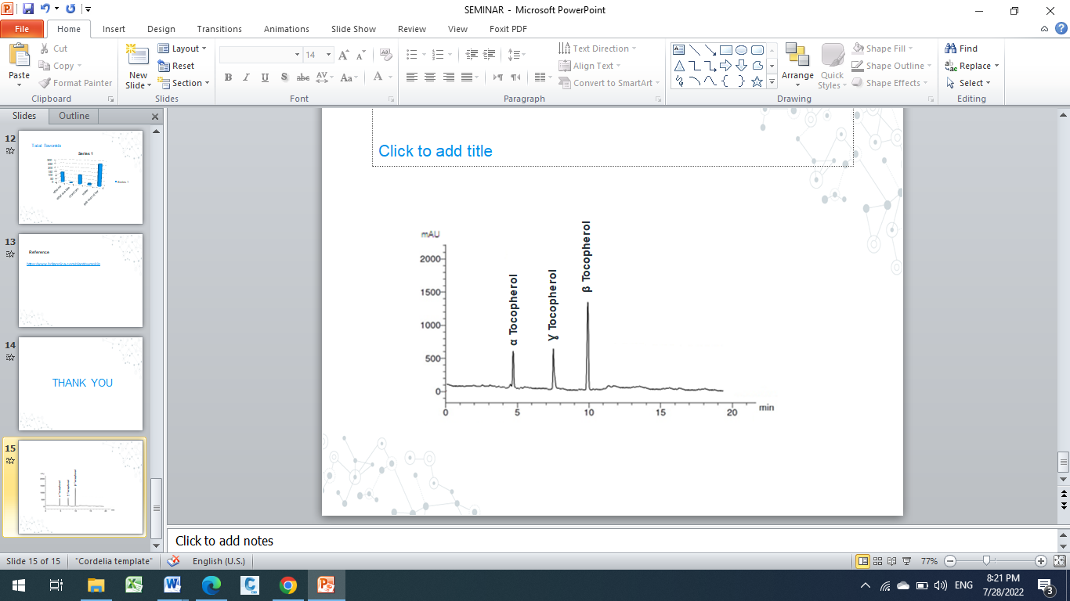

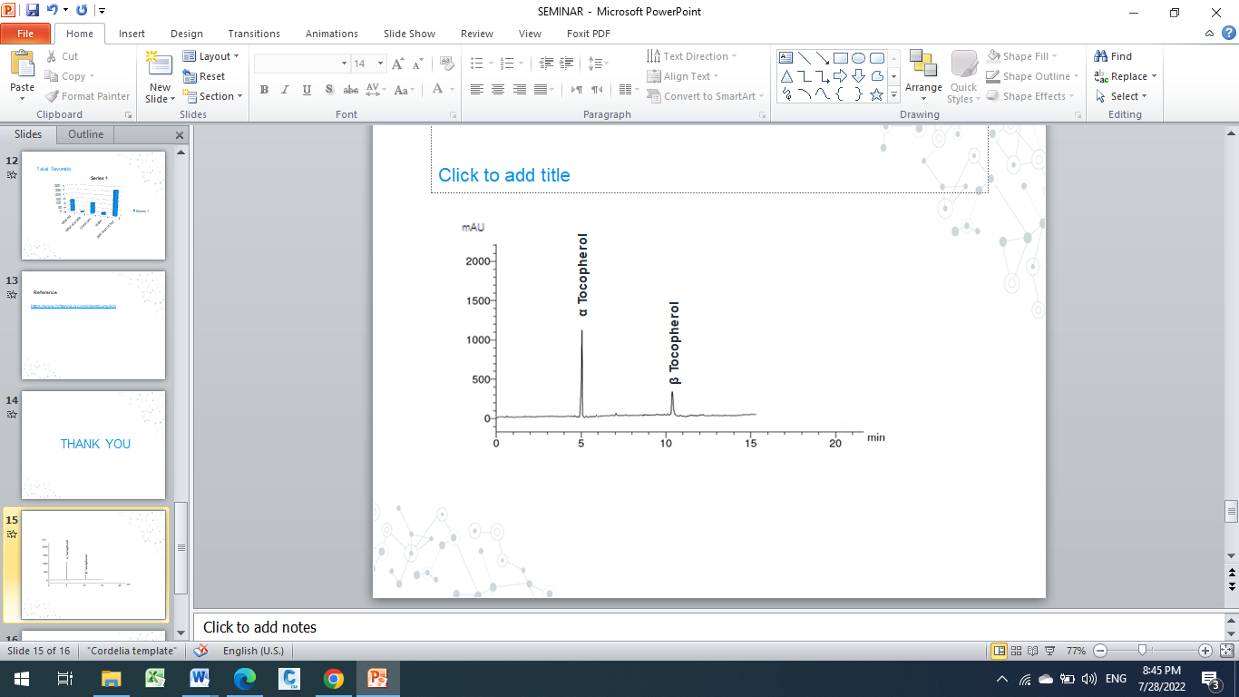Fig (2)
Fig (1)

Total Phenolic compound, total flavonoids and anti-radical activity of Curcubita pepo leaves:
Data presented in (Table 4) show the highest yield was in the water extract (22.51 %) followed by ethanol extract (18.09%) then 5.46 % ,5.43% and 6.36%for ethyl acetate extract chloroform extract and petroleum ether extract, respectively. However, total phenolic contents of Curcubita pepo leaves were 97.79,101.03, 89.34, 177.37and 170.23 mg/GAE extract in petroleum ether extract, chloroform extract, ethyl acetate extract, ethanol extract, and water extract, respectively. While, total flavonoids were 93.70, 99.41, 64.55, 123.87 and 22.92 mg/GAE extract in petroleum ether extract, chloroform extract, ethyl acetate extract, ethanol extract, and water extract, respectively.
Antioxidant activity of the ethanolic and water extracts:
The water extract showed the strongest antiradical activity (57.96%) followed by ethanol extract (55.82%) then the Petroleum ether extract (27.55%). The lowest was given by the ethyl acetate extract (25.89%) (Table 4). From the above-mentioned data, it is clear that samples with low content of phenolic compounds have lower antioxidant activity. The antioxidant activity of phenolic compounds is largely determined by the number of hydroxyl groups on the aromatic ring. The high numbers of hydroxyl groups, the greater expected antioxidant activity.
These results are in agreement with (Kulczyński et al., 2020).

Table 4. extract yield, total phenolic, total flavonoid and antiradical activities of different extracts of Egyptian pumpkin leaves.
Parameter  Treatments | Total extract % | Total phenolic  mg GAE/ g extract | Total flavonoids mg QE/ g extract | Antioxidant activity (%)
Petroleum ether extract | 6.36 | 97.79 | 93.70 | 27.55
Chloroform extract | 5.43 | 101.03 | 99.41 | 38.72
Ethyl acetate extract | 5.46 | 89.34 | 64.55 | 25.89
Ethanol extract | 18.09 | 177.37 | 123.87 | 55.82
Water extract | 22.51 | 170.23 | 22.92 | 57.96

Identification of some antioxidant components in Egyptian pumpkin leaves (Curcubita pepo) leaves ethanolic and aqueous extracts by HPLC:
Data presented in Figs. (3,4,5,6) showed the chemical phenolic and flavonoids components of the ethanolic and aqueous extracts of Egyptian pumpkin (Curcubita pepo) leaves.
The results in Figs. (3 and 4) revealed the presence four to five phenolic compound in pumpkin in each ethanolic and aqueous extracts. The highest quantities in ethanolic extract were found to be cinnamic (8.33 µg/mL), syringic (5.10 µg/mL), pyrogallol (1.46 µg/mL), ellagic (0.97 µg/mL) and gallic (0.87 µg/mL). However, the highest quantities in aqueous extract were gallic (12.33 µg/mL), P-coumaric (6.55 µg/mL), caffeic (5.43 µg/mL), ferulic (0.56µg/mL).
On the other hand, the results in Figs. (5 and 6) revealed the presence four flavonoid compounds in Egyptian pumpkin ethanolic and aqueous extracts. The highest quantities in ethanolic extract were kampferol (16.84 µg/mL), apegenin (12.88 µg/mL), quercetin (4.55 µg/mL) and luteolin (1.64 µg/mL). However, the highest quantities in aqueous extract were found to be apegenin (7.69 µg/mL), rutin (4.16 µg/mL), catechin (3.52 µg/mL) and quercetin (3.07 µg/mL).
The results are in line with those reported by Mashitoa et al., (2021) who found that row pumpkin leaves contain gallic acid (14.20mg/kg), protocatechuic acid (81.00 mg/kg), vanillic acid (42.20 mg/kg), syringic acid (14.50 mg/kg), ellagic acid (86.70 mg/kg), p-coumaric acid (2.10 mg/kg) and ferulic acid (2.30 mg/kg)

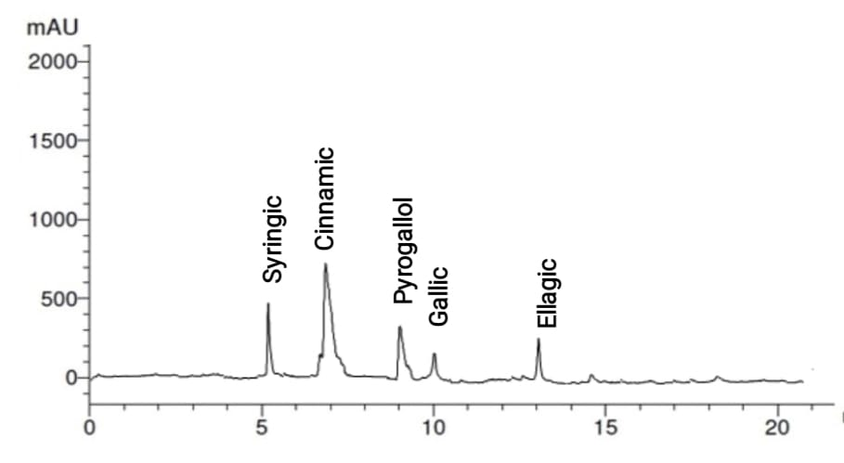

Figure (3): Phenolic compounds of Egyptian pumpkin (Curcubita pepo) leaves ethanolic extracts analyzed by HPLC.

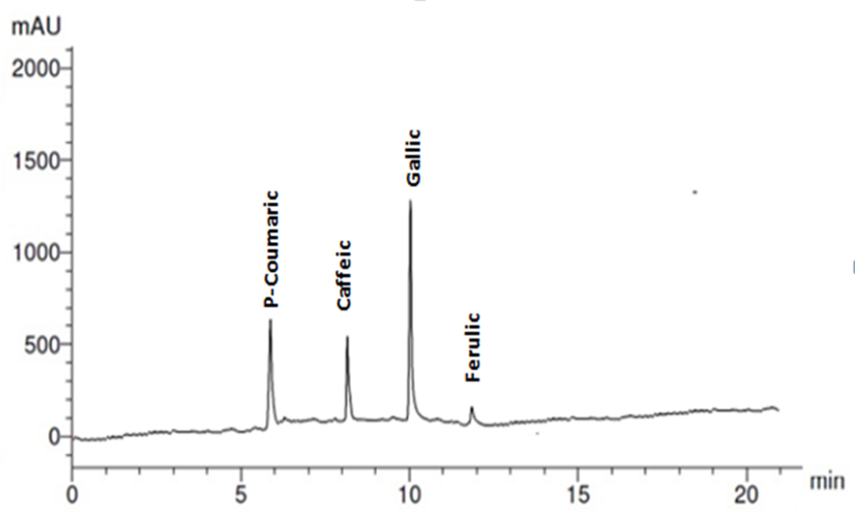
Figure (4): Phenolic compounds of Egyptian pumpkin (Curcubita pepo) leaves aqueous extracts analyzed by HPLC.

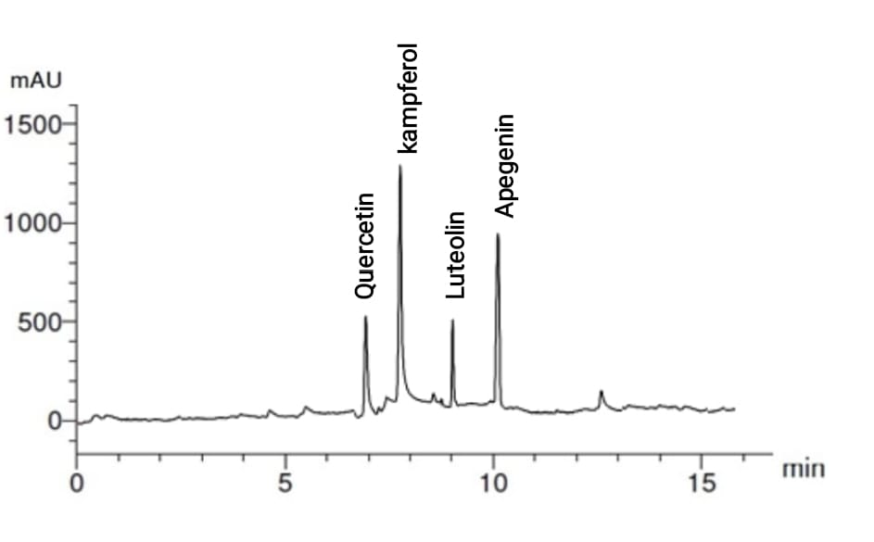
Figure (5): Flavonoids compounds of Egyptian pumpkin (Curcubita pepo) leaves ethanolic extracts analyzed by HPLC.

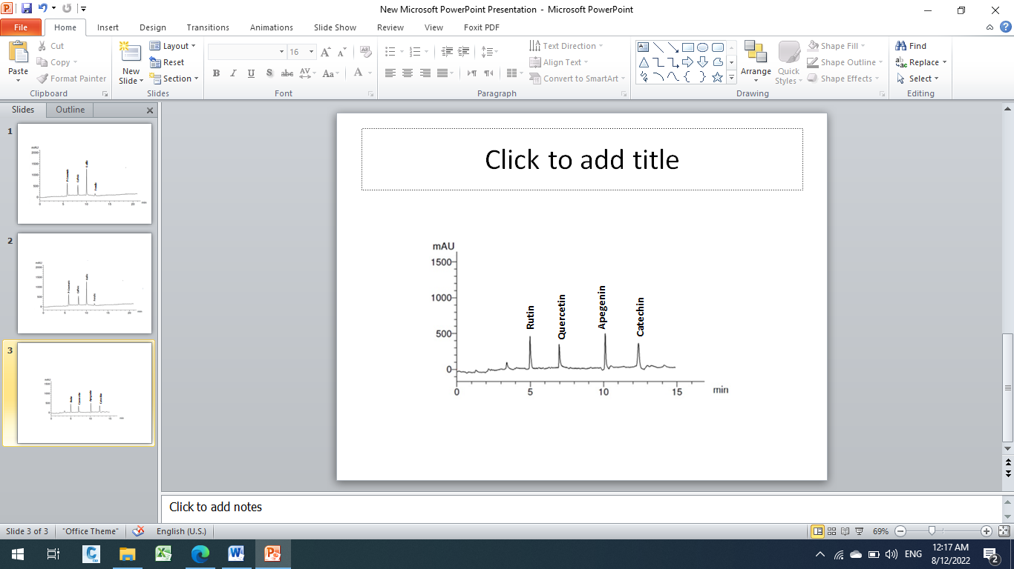
Figure (6): Flavonoids compounds of Egyptian pumpkin (Curcubita pepo) leaves aqueous extracts analyzed by HPLC

In conclusion, the current study supports the presence of several significant phytochemical compounds in the leaves and seeds of the pumpkin (Curcubita pepo). The ethanolic and water extracts showed the presence of many bioactive components with strong antioxidant activity, making it a highly important source of natural antioxidants. Pumpkin seed oil is rich in heart-healthy fats such as omega-6 and omega-3 fatty acids and antioxidants. Also, Pumpkin seed oil can use to improve heart health by lowering cholesterol and reducing high blood pressure. The use of the leaves and seeds of the pumpkin as a natural agent to protect against per-oxidative damage in biological systems connected to diabetes, ageing, and carcinogenesis should be further researched.

References

A.O.A.C. (2019). Official methods of analysis of Analytical ''21th''ED. Association of Official Analytical Chemists, Gaithersburg, Maryland, U.S.A.
Akubugwo, I. E., Chinyere, G. C., and Ugbogu, A. E. (2008). Comparative studies on oils from some common plant seeds in Nigeria. Pakistan J. of Nutr., 7(4), 570-573.
Al Zuhair, H. A. N. A., Abd El-Fattah, A. A., and El-Sayed, M. I. (2000). Pumpkin seed oil modulates the effect of felodipine and captopril in spontaneously hypertensive rats. Pharmacol. Res., 41(5), 555-563.‏
Al-Anoos, I., EI-Dengawy, R., and Hasanin, H. (2015). Studies on chemical composition of some Egyptian and Chinese pumpkin (Cucurbita maxima) seed varieties. Journal of Plant Sci. & Res., 2(2), 1-4.‏
Ayyildiz, H. F., Topkafa, M., and Kara, H. (2019). Pumpkin (Cucurbita pepo L.) seed oil. In M. F. Ramadan (Ed.), Fruit oils: chemistry and functionality. Springer.
Ayyildiz, H. F., Topkafa, M., Sherazi, S. T. H., Mahesar, S. A., and Hüseyin, K. A. R. A.(2021). Investigation of the chemical characteristics and oxidative stability of some commercial cold-pressed oils. Konya Mühendislik Bilimleri Dergisi, 9(4), 904-916.‏
Bahru, T. B., Barkea, T. H., and Sali, A. A. (2018). Investigation of Primary Metabolites in Young Leaf and Fruit of Three Varieties of Pumpkin (Cucurbita pepo) from Gurage Zone, Ethiopia. J.Anal.Bioanal.Tech., 9(407), 2.‏
Bello, M. O., Akindele, T. L., Adeoye, D. O., and Oladimeji, A. O. (2011). Physicochemical properties and fatty acids profile of seed oil of Telfairia occidentalis Hook, F. Int. J. Basic Appl. Sci, 11(6), 9-14.
Cha, Y. Y. (2009). Experimental study on effects of Cucurbita moschata Duch. on
antioxidation. J.Korean Med. Obes Res.,9:57–63.
El-Hadary, A. E., and Ramadan, M. F. (2019). Antioxidant traits and protective impact of Moringa oleifera leaf extract against diclofenac sodium induced liver toxicity in rats. J. of Food Biochem., 43(2), e12704.‏
Hanato,T., Kagawa,H., Yasuhara,T. and Okuda,T.(1988):two new flavonoids and other constituents in licorice root: Their relative astringency and radical scavenging effects. HEMICAL & Pharmaceutical Bulletin 36(6):2090-7
Irnawati, I., Sugeng, R., Sudibyo, M., Anjar, W., and Abdul, R. (2022). Physicochemical properties and antioxidant activities of pumpkin seed oil as affected by different origins and extraction methods. J. of Applied Pharmaceutical Sci., 12(03), 115–122. https://doi.org/10.7324/japs.2022.120312.
IS0, U. (2011).12966-2 Animal and vegetables fat and oils. Gas chromatography of fatty acid methyl esters . Part 2: Preparation of methyl esters of fatty acids. International organization for standardization : Geneva , Switzerland.
Isutsa, D. K. and Mallowa, S. (2013). Increasing leaf harvest intensity enhances edible leaf vegetable yields and decreases mature fruit yields in multi-purpose pumpkin. J. of Agricultural and Biol. Sci., 8(8), 610–61.
Iwuagwu, M. O., Solomon, C. U., and Amanze, J. E. (2018). Physicochemical analysis and characterization of edible oil from seeds of orange (Citrus sinensis L.) and pumpkin (Cucurbita pepo L.). Euro. J. of Biotechno. and Biosci., 4(6), 35-40.‏
Jiao, J., Li, Z. G., Gai, Q. Y., Li, X. J., Wei, F. Y., Fu, Y. J., and Ma, W. (2014). Microwave-assisted aqueous enzymatic extraction of oil from pumpkin seeds and evaluation of its physicochemical properties, fatty acid compositions and antioxidant activities. Food chem., 147, 17-24.‏
Karanja, J., Mugendi, B. J., Khamis, F., and Muchugi, A. (2013). Nutritional composition of the pumpkin (Cucurbita spp.) seed cultivated from selected regions in Kenya.‏ J. of Horticulture Letters, 3(1), 17–22.
Kim, M. J., Hong, C. O., Nam, M. H., and Lee, K. W. (2011). Antioxidant effects and physiological activities of pumpkin (Cucurbita moschata Duch.) extract from different aerial parts. Korean J. of Food Sci. and Technol., 43(2), 195-199.
Kim, M. Y., Kim, E. J., Kim, Y.-N., Choi, C., and Lee, B.H. (2012). Comparison of the chemical compositions and nutritive values of various pumpkin (Cucurbitaceae) species and parts. Nutr. Res. and Practice, 6(1), 21–27.
Ko, J. Y., Ko, M. O., Kim, D. S., and Lim, S. B. (2016). Enhanced production of phenolic compounds from pumpkin leaves by subcritical water hydrolysis. Preventive Nutr. and Food Science, 21(2), 132.‏
Kulczyński, B., Gramza-Michałowska, A., and Królczyk, J. B. (2020). Optimization of extraction conditions for the antioxidant potential of different pumpkin varieties (Cucurbita maxima). Sustainability, 12(4), 1305.‏
Kumar ,S., Kumar, D., Manjusha, S .,Singh, N.,and Vashishta, B. (2008). Antioxidant and free radical scavenging potential of Citrullus colocynthis (L.) schrad methanolic fruit extract. Acta Pharm.,58:215-20.
Lim ,T.K.(2012). Cucurbita pepo L. Edible Med. Non-Medicinal Plants, 3: 281–294.
Liu, Q., Scheller, K. K.,and Schaefer, D. M. (1996).Technical note: A simplified procedure for vitamin E determination in beef muscle. J. Anim. Sci.,74, 2406-2410.
Mashitoa, F. M., Manhivi, V., Slabbert, R. M., Shai, J. L., and Sivakumar, D. (2021). Changes in antinutrients , phenolics , antioxidant activities and in vitro a -glucosidase inhibitory activity in pumpkin leaves ( Cucurbita moschata ) during different domestic cooking methods. Food Sci. and Biotechnol., 30(6), 793–800.
Mathangi, S. (2018). A study on extraction of oil from Pumpkin seed using sun drying and hot air oven drying. Inter. J.of Food Sci. and Nutr., 3(1), 34-36
Muntana, N. and Prasong, S. (2010). Study on total phenolic contents and their antioxidant activities of thai white, red, and black rice bran extracts. Pak.J.Biol. Sci.,13:170-4.
Özbek, A. Z., and Ergönül, G. P. (2020). Chapter 18—Cold pressed pumpkin seed oil. In M. F.Ramadan (Ed.), Cold pressed oils (pp. 219–229). Academic.
Prakash, A. (2007): Assessing bias in experiment design for large scale mass spectrometry-based quantitative proteomics. Mol Cell Proteomics, 6(10):1741-8.
Rakcejeva, T., Galoburda, R., Cude, L., and Strautniece, E. (2011). Use of dried pumpkins in wheat bread production. Procedia Food Sci., 1, 441–447.
Rossell, J. B., and Hamilton, R. J. (1987). Classical analysis of oils and fats in Analysis of Oils and Fats. Elsevier Appl. Sci., New York, 23-32.
Sharma, P., Kaur, G., Kehinde, B. A., Chhikara, N., Panghal, A., and Kaur, H. (2020). Pharmacological and biomedical uses of extracts of pumpkin and its relatives and applications in the food industry: a review. Int. J. of Vegetable Sci., 26(1), 79-95.‏
Singh, A.and Kumar, V. (2021). Nutritional, phytochemical, and antimicrobial attributes of seeds and kernels of different pumpkin cultivars. Food Frontiers, October, 1–12.
Tadmor, Y., Paris, H. S., Meir, A., Schaffer, A. A., and Lewinsohn, E. (2005). Dual role of the pigmentation gene B in affecting carotenoid and vitamin E content in squash (Cucurbita pepo) mesocarp. J. of agric. and Food chem., 53(25), 9759-9763.‏
Wang, S.-Y., Huang, W.-C., Liu, C.-C., Wang, M.-F., Ho, C.-S., Huang, W.-P., Hou, C.-C., Chuang, H.-L., and Huang, C.-C. (2012). Pumpkin (Cucurbita moschata) fruit extract improves physical fatigue and exercise performance in mice. Molecules, 17(10), 11864–11876
Yao, Y., Liu, W., Zhou, H., Zhang, D., Li, R., Li, C., and Wang, S. (2019). The relations between minor components and antioxidant capacity of five fruits and vegetables seed oils in China. J. of Oleo Sci., 19005.

مقارنة التراكيب الكيميائية والخواص الطبيعية والكيميائية والمركبات البيولوجية الأخرى في الاصناف المختلفة لليقطين
هدي محمد رجب، إبراهيم محمد عبدالعليم ,عبدالله السيد الحضري
قسم الكيمياء الحيوية الزراعية – كلية الزراعة – جامعة بنها

يتبع نبات اليقطين عائلة القرعيات ويحتوي القرع وبذور القرع على مجموعة واسعة من العناصر الغذائية الأساسية والفيتامينات و مضادات الأكسدة والمعادن حيث يستخدم في علاج كثير من الامراض وتهدف هذه الدراسه الى دراسة التركيب الكيميائي لبذور أصناف اليقطين المصرية والصينية وكذلك الأوراق المصرية لنبات اليقطين وإستخلاص الزيت وفصل وتفريد الأحماض الدهنيه في البذور و أستخلاص المواد الفعالة بواسطة مذيبات مختلفة وكذلك تقدير نشاط المواد المضادات للاكسده عن طريق DPPH وتقدير المحتوي الكلي للفينولات والفلافونيدات في المستخلصات الكحوليه والمائية .وقد تم تقدير التركيب الكيمائي لبذور أصناف اليقطين المصرية والصينية وكذلك الأوراق، تقدير الخواص الطبيعية والكيميائية لزيت اليقطين للصنفين المصري والصيني وكذلك نسبة الأحماض الدهنية سواء المشبعة والغير مشبعة ، تقدير المركبات الفينولية والفلافونويدات الكلية وكذلك تقدير نشاط المواد المضادة للأكسدة و فصل وتفريد المركبات الفعالة. أوضحت النتائج ان بذور اليقطين كان محتواها من الرطوبة ( 10.37-5.95 ) , البروتين الكلي ( 22.31- 18.81) ,الرماد (4.65- 3.84),نسبة الزيت( 39.65-38.57) والكربوهيدرات( 31.75-28). أوضحت نتائج التحليل الكروماتوجرافى الغازي للأحماض الدهنية لزيت بذوراليقطين اصناف المصري والصيني على أنها تحتوى على نسبة عالية من الأحماض الدهنية الغير مشبعة (87.79-78.99 ) وتم تقدير محتوي المركبات الفينولية و الفلافونويدات و النشاط المضاد للأكسدة وكذلك تحليلها بواسطة جهاز التحليل الكروماتوجرافي السائل. فكان إجمالي محتوى الفينولات والفالفونويدات الكلية ومحتوى النشاط المضاد للأكسدة للمستخلص الايثانولي لليقطين أعلى من المستخلص المائي لليقطين. المستخلص الايثانولي لليقطين كان غني بالمركبات الفينولية. كانت القيم المتحصل عليها هي السيناميك ( 8.33 ميكروجم /مل) , السيرنجيك (5.10 ميكروجم /مل ) , بيروغالول (1.46 ميكروجم / مل ), الايلاجيك ( 0.97 ميكروجم /مل )و الجاليك(0.87 ميكروجم /مل ). بالاضافة الي الفلافونويدات وكانت القيم هي علي التوالي كايمبفيرول (16.84 ميكروجم / مل ) , أبيجينين( 12.88 ميكروجم /مل ) , كريستين (4.55 ميكروجم /مل )و لوتيولين(1.64 ميكروجم /مل ).
الكلمات الدالة :- بذور اليقطين ، مستخلصات اليقطين ، الأحماض الدهنية ،التوكوفيرولات، المركبات الفينولية والفلافونويدية .

